Results and Discussion
Greenhouse gas emissions
Figure 1 illustrates the total Greenhouse Gas emissions (GHG) projections under three scenarios: (i) Business-as-Usual (BAU), (ii) the Expert Scenario, and (iii) the Climate Ambition Scenario (CAS). For both the Expert and CAS scenarios, total emissions, including land use, land-use change, and forestry (LULUCF), are projected to be 0.7% and 17.3% lower, respectively, compared to the 2030 BAU emissions (0.5% and 16.9% lower when excluding LULUCF). Despite the incorporation of ambitious policies across all sectors, neither of these scenarios is projected to meet Mexico's Unconditional Nationally Determined Contribution (NDC) target of a 35% reduction, nor its Conditional NDC target of a 40% reduction relative to the modeled BAU, which diverges from the national baseline updated in 2020.
Nonetheless, both the Expert and CAS scenarios indicate substantial long-term emissions reductions by 2050, with projected reductions of 12.6% and 77.1% in total emissions, respectively (9.2% and 66.9% excluding LULUCF), relative to BAU. However, the CAS policy package fails to meet the country’s mid-century net-zero target. To achieve the NDC targets and attain net-zero emissions by 2050, more stringent and immediate policy actions will be required.
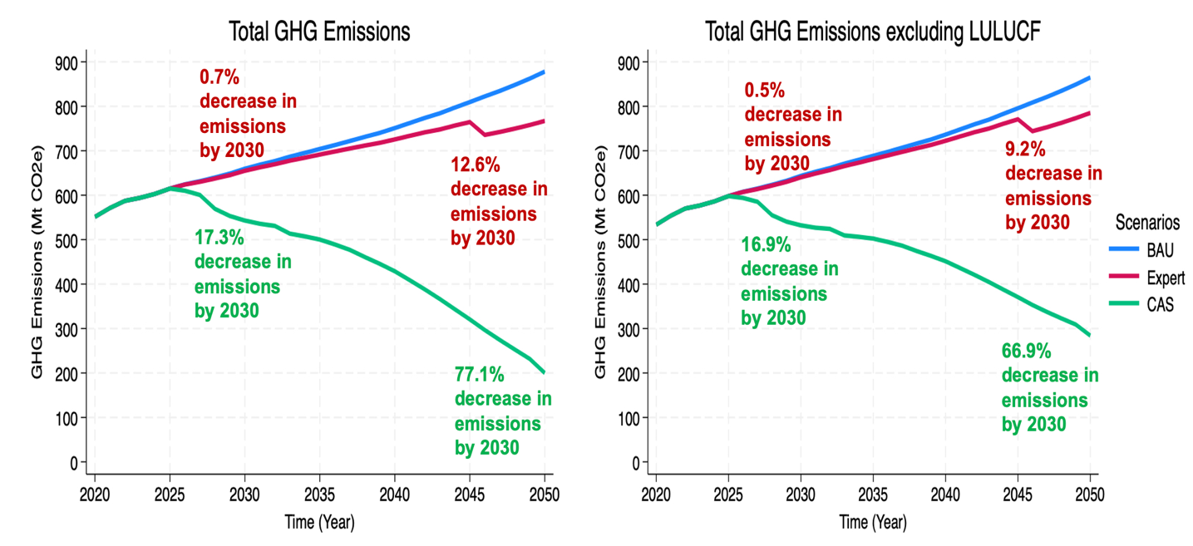
Figure 1: Total greenhouse gas emissions (Mt CO2e).
While climate policies were directed at all economic sectors, the highest emitting sectors – transport, industry, and electricity – were particularly important to focus on. The sectoral analysis highlights where policy interventions can succeed and where urgent actions are needed to align with national climate objectives (Figure 2). The electricity sector emerges as the decarbonization leader, achieving 35.5% reductions by 2030 and 86.1% by 2050 through renewable energy deployment and early coal and oil phase-out strategies. Industry follows as the second-best performer with 18.6% reductions by 2030 and 77.3% by 2050, reflecting effective implementation of fuel shifting, energy efficiency, and F-gas controls. The LULUCF sector shows transformative progress, becoming a carbon sink by 2050 (-84.5 MtCO2e), demonstrating effective land management practices, conservation and reforestation efforts, and a shift to more sustainable diets. Transportation's moderate progress of 9.4% by 2030 and 66.5% by 2050 indicates a gradual but steady transition to stricter fuel efficiency standards, improved public transport systems – including a shift to trains and other sustainable transport modes – and electric vehicles penetration in private, public, and commercial sectors. In buildings, both the residential (5.8% by 2030 and 70.6% by 2050) and commercial (5.9% by 2030 and 75.3% by 2050) sectors show similar patterns, reflecting successful but delayed efficiency improvements. However, the agriculture and waste sectors emerge as critical concerns, with minimal reductions by 2030 (4.3% and 14.6% respectively) and modest improvements by 2050 (19.8% and 53.4%), signaling insufficient policy attention and technological adoption in these areas.
Finally, the analysis of total GHG emissions by sector suggests that while Mexico is on a promising trajectory for long-term emissions reduction, the CAS scenario may not be sufficient to achieve its current NDC targets. Strengthening mitigation efforts, especially in the immediate deployment of renewable energies, along with the adoption of sustainable practices in the transport, industry, and agriculture sectors, are essential to bridge both the immediate gap from the unconditional and conditional targets, as well as achieving net-zero by 2050.
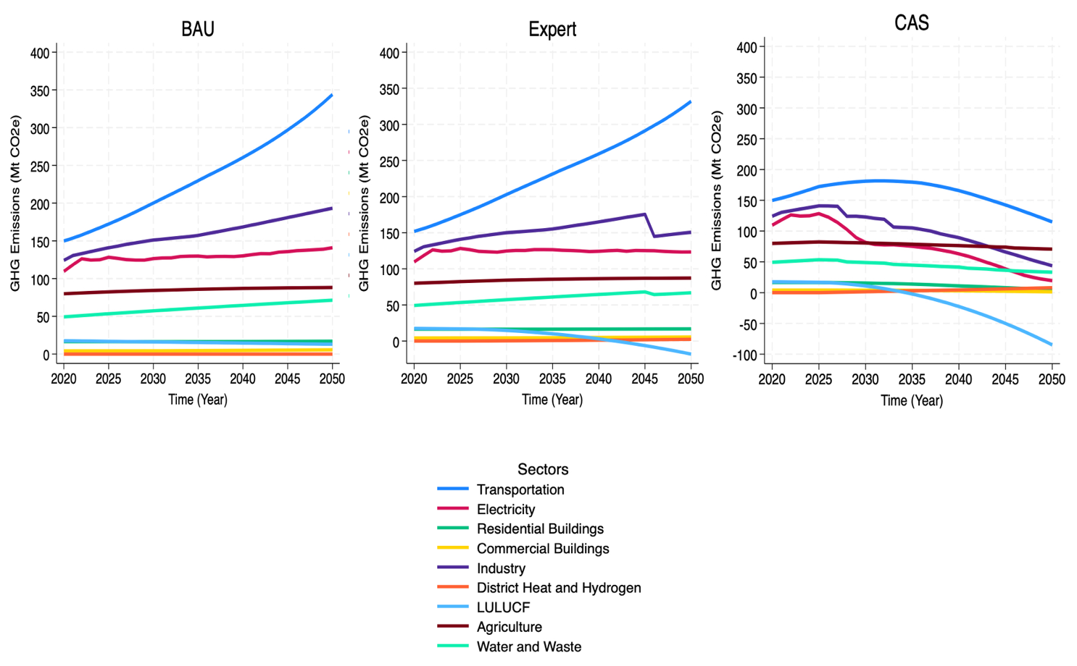
Figure 2: Greenhouse gas emissions by sector (Mt CO2e).
Electricity Generation
The analysis shows a clear transition from fossil fuels to renewable energy across the BAU, Expert, and CAS scenarios, with significant differences in ambition and outcomes (Figure 3). In the BAU scenario, fossil fuels dominate, with natural gas providing 49.7% of electricity in 2030 and 46.7% in 2050, while renewables like solar and wind grow but remain secondary, contributing 40.3% in 2030 and 50.7% by 2050. The Expert scenario shows moderate progress, reducing coal to 4.8% in 2030 and 2% in 2050, while solar and wind increase to 41.6% and 52.7%, respectively.
The CAS policy scenario implies changes in the evolution of electricity generation in Mexico over the next 25 years. By 2030, Mexico is expected to reach its 45% renewable energy target, driven by strong growth in solar PV (31%) and wind (16%) under the CAS scenario. Assuming 60% of solar PV is installed on rooftops, over 1.75 million homes could provide families living in poverty with access to clean energy and reducing the cost of electricity. No new power generation with natural gas is installed after 2030, and thus capacity generation declines 94% by 2050. Fossil fuel generation from coal and heavy fuel oil is phased out by 2030, highlighting Mexico's accelerated shift towards a low-carbon energy matrix.
Overall, the CAS scenario illustrates the radical change needed to meet climate goals, heavily prioritizing renewable energy, while BAU and Expert scenarios reflect slower, less impactful transitions. This scenario suggests incremental progress that falls short of the systemic changes necessary to limit global warming, emphasizing the need for aggressive climate policies and technological advancements to achieve sustainable energy systems.
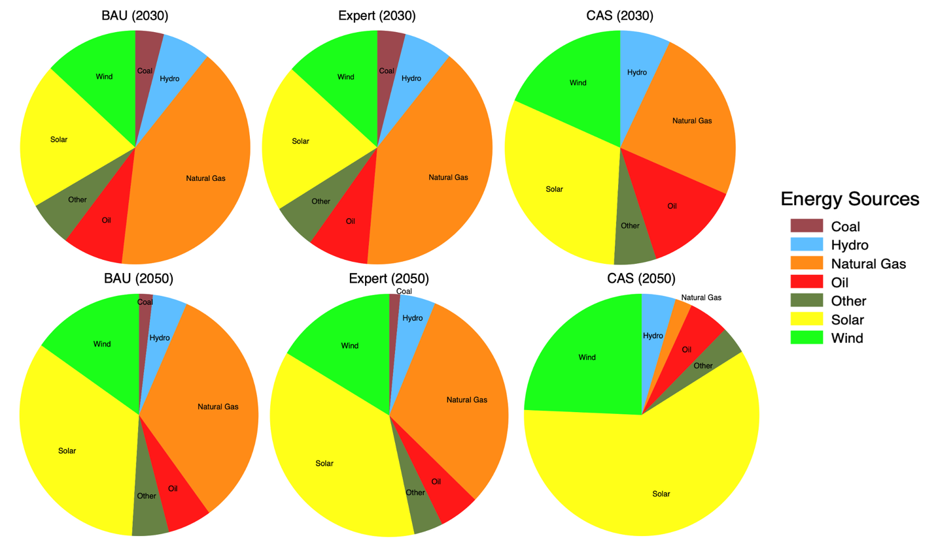
Figure 3: Share of electricity generation by energy source (%).
Economic impacts of climate policies
As part of this analysis, the economic impacts under the Expert and CAS scenarios were assessed, identifying potential benefits and tradeoffs between climate and economic goals. Specifically, fluctuations in domestic employment, GDP, national debt, government cash flow, and economic costs were examined in the policy package.
In 2030, the GDP under the Expert scenario is projected to be $562 million, while the CAS anticipates $3.57 billion. By 2050, these figures will rise significantly, with the Expert scenario reaching $3.809 billion and the CAS increasing to $32.41 billion. The CAS scenario consistently demonstrates a considerably higher GDP projection compared to the Expert scenario, reflecting stronger economic growth under its assumptions (Figure 4).
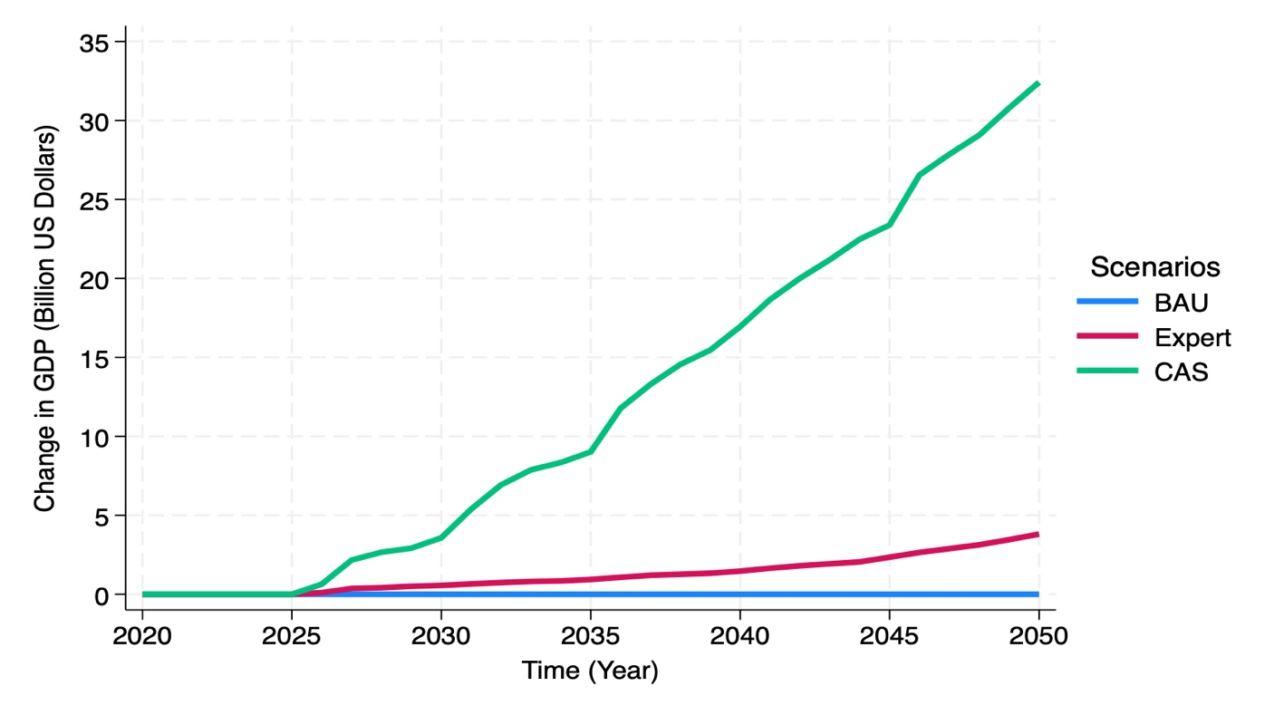
Figure 5: Gross Domestic Product (Billion US Dollars).
The GDP by industry under the Expert and CAS scenarios highlights trends in various sectors from 2020 to 2050. In the Expert scenario, agriculture and oil and gas extraction grow steadily, while sectors like coke and refined petroleum products and electric power generation show fluctuating negative values, indicating transitions and challenges. The CAS scenario shows a rapid rise in GDP for oil and gas extraction, food products, and real estate activities, while coke and refined petroleum products experience significant declines. Economic growth is primarily driven by innovative policies such as carbon pricing and buy-domestic initiatives, which enhance sectors like food production and industry, as well as financial and business services. Additionally, the implementation of electric vehicle policies, renewable energy initiatives, and the early phase-out of coal and oil will contribute to GDP growth by reducing domestic fossil fuel consumption thereby increasing fuel exports (Figure 6).

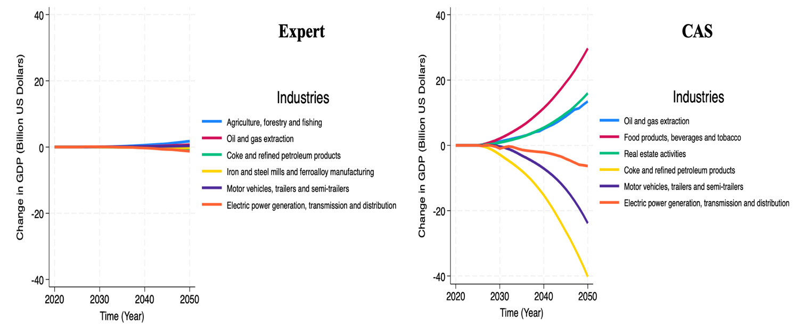
Figure 6: Gross Domestic Product by industry(Billion US Dollars).
Total employment follows similar trends as GDP in both Expert and CAS scenario (Figure 7). Job growth over time exhibits distinct trajectories, with CAS significantly outpacing the Expert scenario in scale. By 2030, jobs in the Expert scenario reach 15,542, while CAS achieves a far larger 87,487, showcasing CAS's rapid acceleration during the initial years of growth. By 2050, the disparity widens substantially: the Expert scenario accounts for 198,992 jobs, whereas CAS reaches 1.33 million, demonstrating a factor of nearly 7 times greater job creation under CAS.
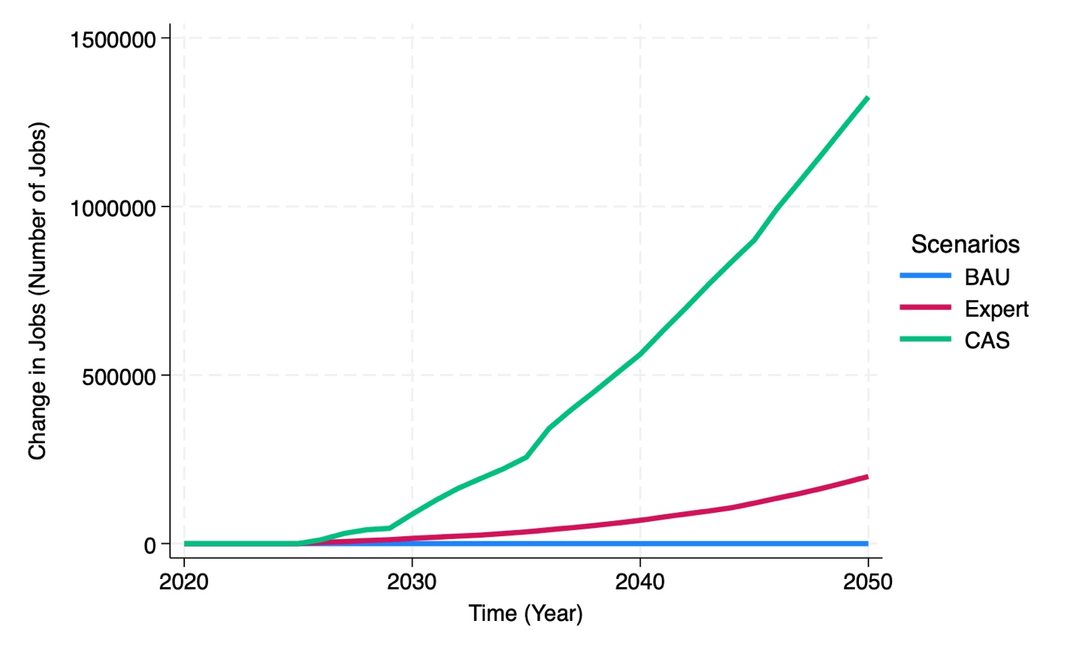
Figure 7: Domestic jobs (Number of Jobs).
An analysis of employment trends across industries highlights notable disparities between the Expert and CAS scenarios. The CAS scenario demonstrates a more dynamic and transformative trajectory compared to the Expert scenario. CAS significantly outpaces the Expert scenario in job creation across most industries, with especially strong growth in service-oriented and labor-intensive sectors like other business sector services and private households. While the transition away from animal-based products leads to initial job losses from both scenarios in related sectors, the economic growth driven by these policies generates new opportunities in sustainable agriculture, forestry, and fishing. Conversely, employment declines in the coke and refined oil products, non-electric motor vehicles, trailers and semi-trailers, and fossil electricity generation sectors are anticipated due to early retirement policies and the shift toward clean vehicle technologies. Overall, the CAS scenario fosters a more robust job market, though efforts will be needed in training to facilitate the transition for workers from the affected industrial sectors to sustainable and higher quality jobs incorporating a gender perspective and social inclusion approach.
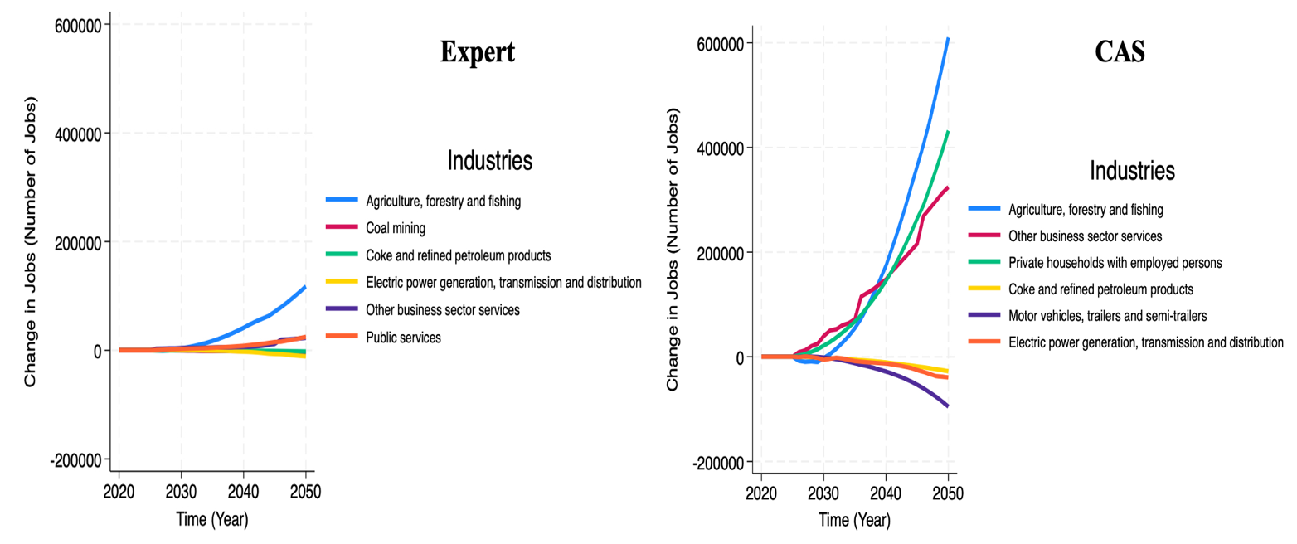
Figure 8: Domestic jobs by industry (Number of Jobs).
Mexico’s national debt is reduced under the Expert and CAS scenarios, with significant improvements projected over time (Figure 9). In 2030, the national debt reduction under the Expert scenario is projected to be $160.79 million, while the CAS scenario shows a significantly higher reduction of $4.41 billion. This represents a gap of over 27 times, highlighting that the CAS scenario leads to a much more substantial improvement in fiscal health in the short term. By 2050, the difference between the two scenarios becomes more pronounced. The Expert scenario achieves a national debt reduction of $4.66 billion, while the CAS scenario reaches $107.9 billion. This marks a difference of approximately 23 times greater, further emphasizing the capacity of the CAS scenario to reduce national debt over the long term. Overall, the results demonstrate that the CAS scenario offers more significant debt reduction than the Expert scenario, reflecting the enhanced fiscal benefits of the policies under CAS.

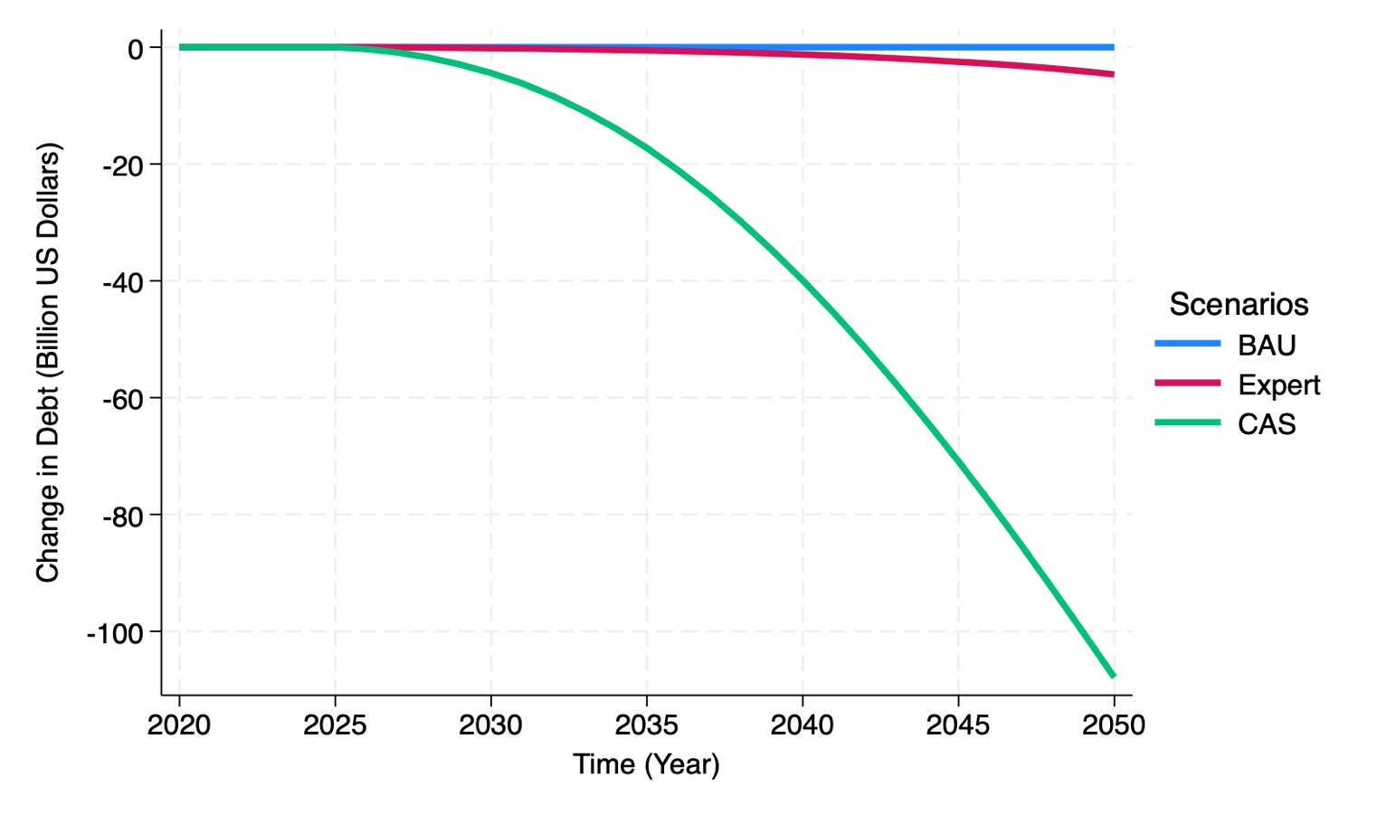
Figure 9: National debt (Billion US Dollars).
In addition to reducing national debt, the government’s cash flows benefit significantly from increased carbon tax revenue, decreased fuel subsidy expenditures, and reduced interest payments on the national debt (Figure 10). By 2030, with a carbon tax of $14 per ton of CO2e, revenue under the CAS scenario is projected to be $6.12 billion—nearly ten times higher than the $640.31 million generated under the Expert scenario. Similarly, savings on interest payments are estimated at $203 million with the CAS scenario, compared to only $7.31 million with the Expert scenario. By 2050, the advantages of the CAS scenario become even more pronounced. With a carbon tax of $90 per ton of CO2e, revenue is expected to increase to $27.7 billion under the CAS scenario, significantly surpassing the $6.24 billion projected under the Expert scenario. Interest payment savings also demonstrate this stark contrast, with the CAS scenario delivering $6.91 billion in savings compared to $283.33 million with the Expert scenario. These substantial benefits under the CAS scenario more than offset the decline in fuel tax revenues as Mexico transitions away from fossil fuels. Overall, while both scenarios enhance the government’s fiscal health, the CAS scenario provides far greater financial capacity, enabling more robust climate-smart investments in mitigation and adaptation efforts.
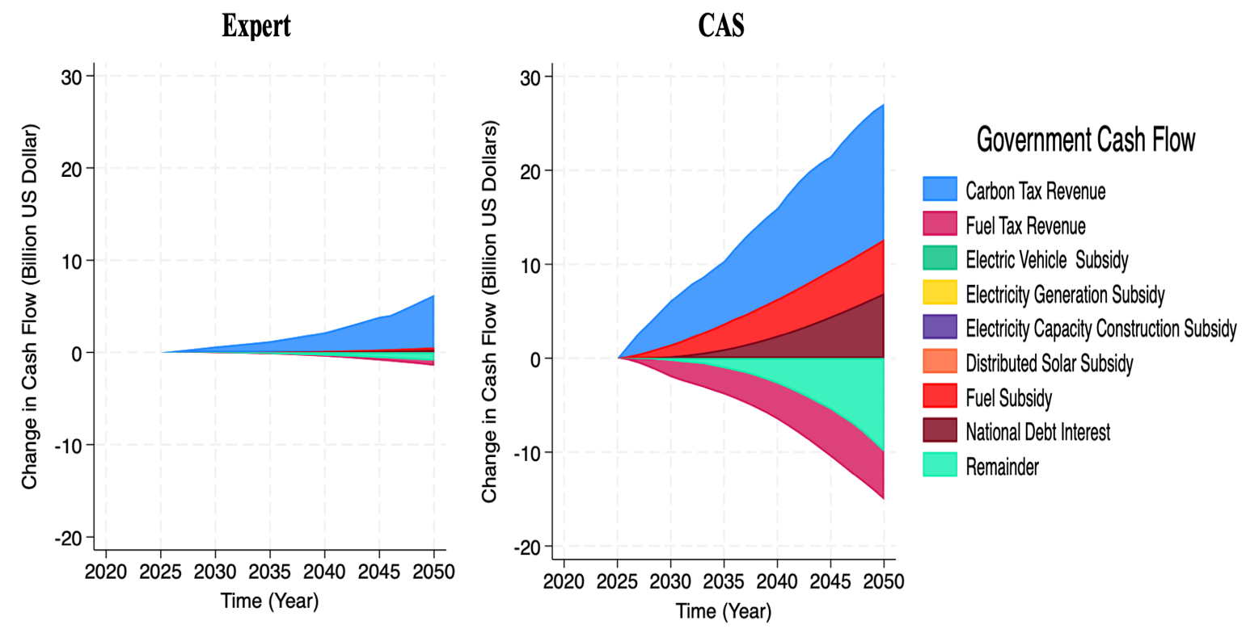
Figure 10: Government cash flow by entity (Billion US Dollars).
Costs and savings from implementation
The costs of implementation are determined by analyzing the change in capital expenditures along with operations and management costs (Figure 11). The analysis shows a significant increase in investments from both public and private sectors under both the Expert and CAS scenarios, but with two distinct approaches to financing climate action. In 2030, the Expert scenario sees an increase in CAPEXP of $583.48 million and OPEXP of $2.27 million. In contrast, the CAS scenario shows a much higher increase in CAPEXP at $4.65 billion, with a negative OPEXP of $2.11 billion. The stark difference in CAPEXP highlights the CAS scenario's more aggressive investment strategy, while the Expert scenario maintains a more stable and moderate expenditure pattern. By 2050, the Expert scenario projects CAPEXP at $3.09 billion and OPEXP at $2.81 billion, indicating growth in both expenditures. In contrast, the CAS scenario shows a decrease in CAPEXP of $26.56 billion and OPEXP of $38.84 billion. These decreases under the CAS scenario by 2050 indicate a major shift in fiscal dynamics, driven by a phase-out of fossil fuel investments and a shift toward climate-friendly policies, leading to significant reductions in both operational costs and capital expenditures.

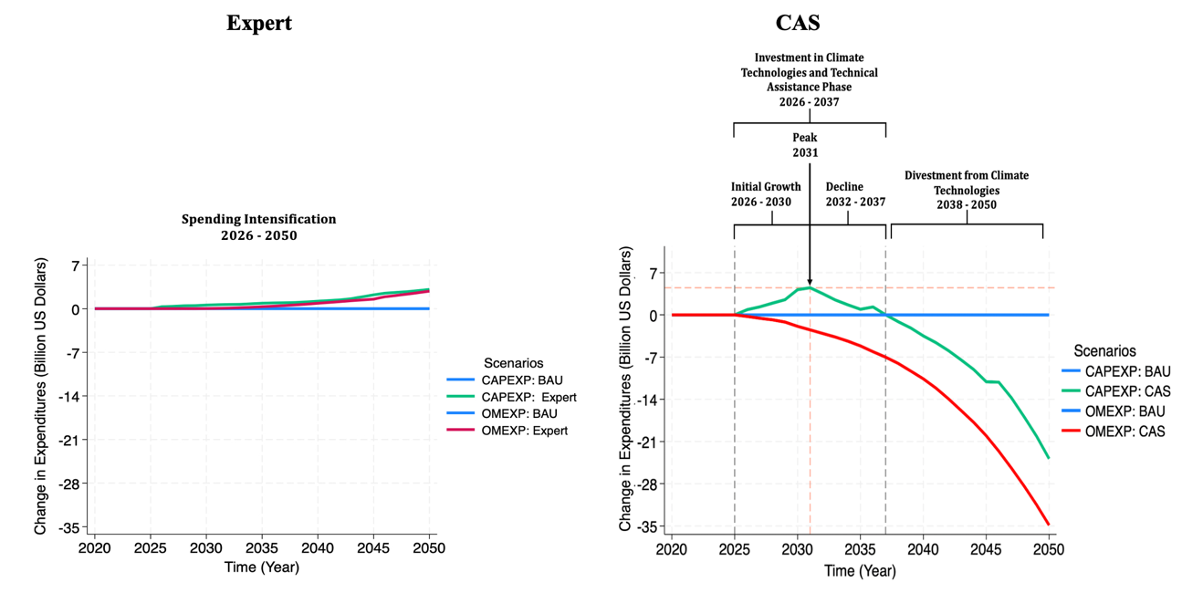
Figure 11: Costs of implementation (Billion US Dollars).

While the policy package involves upfront investments, it is anticipated to have significant savings over time. The Expert scenario sees increases in savings from avoided climate damages, household savings, social benefits from emissions reductions, and monetized benefits from avoided premature mortality. By 2030, total savings reach $489.71 million, and by 2050, the total savings accumulate to $18.87 billion. The consistent rise in savings reflects the gradual approach to climate action in this scenario, which focuses on stable, long-term growth. The CAS scenario, by contrast, exhibits a much more aggressive approach, with substantial gains in savings. By 2030, the total savings in the CAS scenario are $13.47 billion, and by 2050, they peak at $119.45 billion. This sharp increase reflects the upfront investments in climate technologies and policies under the CAS, leading to a rapid acceleration of economic and social benefits, especially through emissions reduction and avoided climate damages.

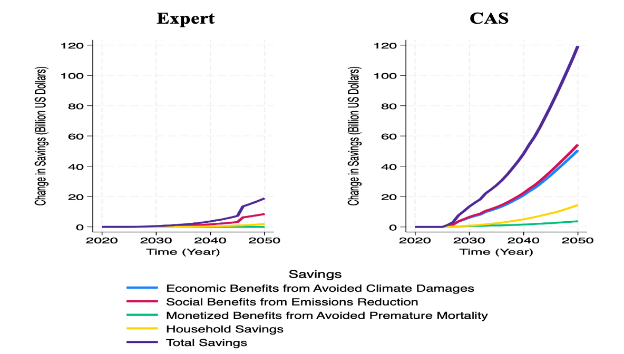
Figure 12: Savings from implementation

